 | Departamentul Automatică şi Informatică Industrială  Facultatea Automatică şi Calculatoare  Universitatea POLITEHNICA din Bucureşti | 

LUCRARE DE LICENŢĂ

Titlu lucrare

Coordonator Absolvent
Prof. Anca Daniela IONITA Andrei SARANDAN

2024

Contents
Contents 2
Part I - General Aspects 4
1 Introduction 5
2 Inclusion of the study's domain of interest 6
2.1 Low Emission Zones 6
2.2 LEZs throughout Europe 6
2.3 Current situation in Europe 7
2.4 LEZs in Northern Europe 8
2.5 Forecasts 9
2.6 Current context regarding LEZs 9
3 Thesis Statement 10
3.1 Addressing the Complexity of Navigation throughout LEZs 10
3.2 Similar applications 11
3.2.1 Green-Zones.eu 11
3.2.2 Urban Regulations 11
3.3 Thesis Impact: Contributions and Implications 12
4 Technical Documentation 13
4.1 Software Technologies 13
4.1.1 Hypertext Markup Language 13
4.1.2 Python 14
4.1.3 Flask 14
4.1.4 SQLite 15
4.1.5 JavaScript 16
4.1.6 APIs 17
4.2 Backend Development 18
4.2.1 Foundations 18
4.2.2 Route handling in Flask 18
4.3 Frontend Development 19
4.4 Software Development Moldes and Tools 20
4.4.1 AJAX 20
4.4.2 OOP 20
4.4.3 Database Management Tools 20
4.4.4 Integrated Development Environment (IDE) 20
4.5 Development Frameworks and Platforms 20
4.5.1 Integration of Technologies 20
4.5.2 Frontend and Backend Interaction 20
4.5.3 Responsive Design and Cross-Browser Compatibility 20
PART II – PROJECT CONTRIBUTIONS 21
5 Development Rationale and Methodology 22
5.1 Addressing the Issue 22
5.2 Proposed Solution 22
6 Development Methodology 22
6.1 Analysis and Requirements Specification 22
6.1.1 Information Sources 22
6.1.2 Use Cases 22
6.1.3 Functionalities 23
6.1.4 Constraints and Other Non-functional Requirements 23
6.2 Design Elements 24
6.2.1 Architecture 24
7 Description of the Practical Application 24
7.1 User Guide 24
7.2 Application Verification and Validation 24
7.3 Results Obtained 24
8 Conclusions 24
Bibliography 25
Appendix 1. Code Snippets 27

Part I - General Aspects

1 Introduction

The increasing concerns regarding pollution necessitate the implementation of various measures aimed at enhancing air quality. Pollution, stemming from a multitude of sources and presenting in various forms, possesses significant threats to both human health and the environment. Among them, vehicular emissions stand out as one of the most prominent forms of pollution. This is mostly concerning in the urban settlements and metropolises that are suffocated by the raising number of cars, with an average of nearly one car per 1-2 individuals. Passenger cars stand out as a major polluter, accounting for 61% of total CO2 emissions from EU road transport [1].
The European Union is striving to drastically reduce air pollution by implementing new legislation aimed at pushing new vehicles towards achieving zero CO2 emissions. However, the actual progress has proven to be much slower than we have hoped.
The primary methods for reducing CO2 emissions from vehicles are manufacturing more efficient cars and changing the fuel type by transitioning to more eco-friendly ones, ideally derived from green or regenerative energy [1]. Even though electric and hybrid cars are taking a considerable part of the newly registered vehicles, the issue of older, higher-emission vehicles must not be overlooked.
Designing a schema to reduce the pollution proves to be a challenging aspect, yet necessary. Such schemas, known as Urban Vehicle Access Regulations, have been implemented in many West European cities. These rules include things such as low emission zones, zero emission zones, tolls for driving in congested areas, creating more space for pedestrians, changing parking rules, and limiting traffic in certain areas. The goal is to comply with the newly adopted air quality standards, while also improving traffic.
Generally, vehicle categorization and access are based on the vehicle type, fuel type and emission class (Euro emission standard). Additionally, such regulations usually impose some form of toll or fee that must be paid in order to gain access into a specific zone.
Out of the many existing forms of Urban vehicle Access Regulations, most of them are known as Low Emission Zones (LEZs), accounting for 73% of the current regulations [2].
The scope of this thesis revolves around developing an application geared towards improving user experience in navigating Low Emission Zones (LEZs), with a focus on providing information and validating access within LEZ cities. Since this concept is very new and still in development, the main objective is to raise awareness and promote their acceptance. LEZs may pose complexities for many individuals, hence efforts are needed to simplify comprehension and facilitate access.
The aim is to create an intuitive web application that provides information and help to access these Low Emission Zones throughout Europe. Since this is an ever-changing topic, the database system is incorporated to cover the regulations that are effective in July 2024. It is designed so that it can be adapted to ongoing updates, in order to provide valid information to the end-user.

2 Inclusion of the study's domain of interest

2.1 Low Emission Zones

Low Emission Zones (LEZs) are geographical areas, usually located in large urban settlements, where specific restrictions are imposed on more polluting vehicles. Typically, this kind of vehicles are prohibited from entering the zone, although in certain instances, a fee can be paid for access. Low Emission zones have proved to be a great method of reducing air pollution, especially targeting fine particles such as NO2, which are highly correlated to several respiratory diseases.
The concept of environmental zones originated in Sweden in 1996 and were initially created to reduce both air pollution and large vehicles noise. These zones were eventually replaced by national regulations that comply with EU environmental standards and now only cover heavy-duty vehicles [3]. Such examples were later adopted by other countries and are now widely spread throughout Western Europe.
In Europe, the three main air pollutants of concern are represented by nitrogen dioxide (NO2), particulate matter (PM, also referred to as PM10 or PM2.5 depending on the particle diameter), and ozone. The principle behind the functionality of Low Emission Zones is to restrict as much as possible the access of highly polluting vehicles. This can be achieved either by raising the costs of access through fees or tolls or by completely forbidding the access. Another approach would be retrofitting older vehicles to meet modern regulations, by adding diesel particle filters (DPF). These filters could elevate the vehicle to a slightly higher emission standard [5].

2.2 LEZs throughout Europe

Considering the transformative nature of a Low Emission Zone, defined by its main purpose, to reduce pollution by limiting the vehicle access in designated areas, such solution cannot be implemented overnight.
The United Europe propose a strategy to gradually implement such areas in the following years [4]. This approach facilitates the acceptance and adoption of a low emission zone and allows each nation to fine-tune the schemas, to better fit the needs and possibilities of the country and the citizens. Local authorities can better manage the requirements and priorities, enhancing the effectiveness to reduce the pollution as much as possible.
While there is no clear recipe for implementing a low emission zone in a big urban settlement, giving free-will for the nations to create and personalize theirs, gave birth to many such forms. On one hand, having more variations of a regulation, means more case-studies and a faster evolution of this field. Even in a short time, the regulations are now found in many different forms, some more effective than the other and some more simple to use than the other.
While each approach presents its own set of merits and drawbacks, the end objective remains the same. The Low Emission Zone term can be found under a different name, depending on the national law it has been regulated by. For example, in Germany, low emission zones are known as "Umweltzonen", while in France, it is referred as ZCR ("Zone à Circulation Restreinte"). Both terms define strict criteria in order to separate vehicles based on Euro standard. In order to clearly differentiate the categories, a sticker is assigned for each vehicle and it is required to be displayed in the windshield, in order to be visible for the authorities.
Over more, each locality has the flexibility to implement its own restrictions based on the emission stickers displayed on vehicles' windshields.
The main difference between the LEZ regulations in Germany and France lies in the criteria selected for classification. In Germany, vehicles can be assigned one of the three available emission stickers based on their Euro emission standards. Green being the cleanest and most environmentally friendly, followed by yellow and then red for the highest emissions. These stickers were first introduced in 2008 and because of the regulations in place at that time, a diesel vehicle now needs to be at least EURO 4 to be eligible for the green sticker [6].
On the other hand, France introduced the Crit'Air vignette system in 2017. Crit'Air stickers are also color-coded and classify vehicles based on emissions. However, France has designated six categories ranging from green, which is only designated for 100% electric and hydrogen vehicles to dark gray for vehicles with high pollution.
While both systems serve a similar purpose of regulating vehicle emissions within urban areas, the specific criteria for classification and the appearance of the stickers differ between the two countries. Crit'Air vignette also comes with a long-term strategy to introduce this schema throughout the cities with more than 150.000 inhabitants [7]. Also, the plan is to gradually tighten the standards as the years advance, by switching the minimum required sticker for access to the next one. As an example, in Paris, regulations in place since 1 June 2021, impose minimum Crit'Air sticker 3 (diesel EURO 4 and EURO2 petrol cars). The year 2025 will impose Crit'Air sticker 2 (minimum diesel EURO 5 and EURO4 petrol cars). Initially this restriction was scheduled to be implemented starting from 1st of July 2023 but had to be postponed [8].

2.3 Current situation in Europe

The European Union legislation encourages member states to establish their own regulations for Urban Vehicle Access Regulations, such as Low Emission Zones (LEZs). The decentralized nature of this approach allows each country to tailor the policies to better fit the circumstances. National authorities must take into account different factors such as population density, existing infrastructure, public transport, etc. Furthermore, within each country, the local responsible set specific regulations within their jurisdiction and the national framework.
This decentralized structure offers several advantages. Firstly, it facilitates the implementation of diverse strategies, providing a range of test cases to evaluate the efficacy of different models in addressing air pollution and promoting sustainable urban mobility. Additionally, it acknowledges that national governments are best positioned to understand their own environmental challenges and devise targeted solutions accordingly.
However, this system can also result in complexity and inconsistency for the population. With regulations varying not only between countries but also among different municipalities within the same country, drivers may encounter a patchwork of rules and requirements as they navigate through different regions. This can lead to confusion and logistical challenges, particularly for individuals who frequently travel between areas with differing regulations.
As exemplified by the contrasting Crit'Air sticker system in France and the Umweltplakette system in Germany, where nine stickers are utilized across two countries, each available exclusively within its respective jurisdiction and governed by distinct criteria, the fragmentation of regulations can exacerbate the burden on the populace. The proliferation of unique standards and administrative processes adds layers of complexity and administrative burden, underscoring the challenges inherent in coordinating environmental policies across diverse geographical and political boundaries.

2.4 LEZs in Northern Europe
The varying standards and regulations across these Northern European countries add another layer of complexity for individuals seeking to access low emission zones. This divergence underscores the need for a comprehensive understanding of the specific requirements and sticker systems in place in each country, further complicating the experience for users and necessitating careful planning and compliance measures when traveling across borders.
Considering the aforementioned context, accessing a low emission zone becomes a significant challenge for the average individual. The multitude of European countries that have adopted a form of Low Emission Zone and the diverse range of regulations taken into consideration create a complex navigation landscape.
In addition to the stickers present in countries like France and Germany, the European Low Emission Zone schema is further compounded by a different strategy in Northern Europe. Nations in this region, such as Denmark (Miljøzone), Sweden (Miljözon) and the Netherlands (Milieuzone) implement their own systems for emission regulations. The core principle remains the same, to reduce pollution by restricting the highly polluting vehicles access in city centres. Also, the entry requirements for low emission zones in each country differ.
Within these frameworks, nationally registered vehicles are automatically included in a nation-central database, drastically facilitating the process of complying and also the efficiency of the LEZ. However, foreign vehicles, need to register online, typically prior to entering the LEZ to avoid penalties. This registration only enables access to the zone for vehicle that comply with emissions standards set by local authorities.
Northern Europe Low Emission Zones are primarily enforced through camera systems, designed to capture the vehicle’s registration number before entering the designated area. This system cross-references the captured registration number with the central database to verify the vehicle’s eligibility for entry. This automated approach enhances efficiency and accuracy while reducing reliance on and costs for manual inspections.
Overall, this digital registration and enforcement model streamlines the process for registered vehicles while promoting compliance with LEZ regulations, ensuring effective management of air quality within urban environments.

2.5 Forecasts
According to the report made by statista.com [9], forecasts expect a significant expansion of Low Emission Zones (LEZs) throughout Europe. Projections indicate a substantial increase in the number of LEZs, with an estimated total of 510 zones across 17 countries. This increase highlights the European Union's commitment to mitigating air pollution and promoting sustainable urban development throughout the continent.

Country | Number of LEZ in 2022 | Project number of LEZs by 2025
Italy | 172 | 172
Germany | 78 | 78
United Kingdom | 17 | 18
Netherlands | 14 | 14
France | 8 | 42
Sweden | 8 | 8
Austria | 6 | 6
Denmark | 4 | 4
Spain | 3 | 149
Belgium | 3 | 4
Norway | 3 | 3
Czechia | 1 | 1
Finland | 1 | 1
Greece | 1 | 1
Portugal | 1 | 1
Poland | 0 | 2
Bulgaria | 0 | 3

Tabel 1. Number of Low-Emissions Zones in Europe 2022-2025[9]

2.6 Current context regarding LEZs

The multitude of terms used to designate Low Emission Zones (LEZs) across Europe drives up the complexity for regular individuals when navigating these environmental zones. While the purpose for each designation remains to reduce emissions and improve air quality, the linguistic and cultural diversity adds layers of intricacy.
From "Umweltzonen" in Germany to " Miljøzone " in Denmark, and " Distintivo Ambienta" in Spain, the wide terminology presents a challenge for users seeking clarity and understanding. This complexity extends with regulations implemented in France, Belgium, England, Denmark, Sweden, Norway, Hungary, and Italy, each with its unique terminology and approach.
The effectiveness of Low Emission Zones is directly linked to both the rigor of the implementation but also the level of compliance. While the establishment of a LEZ is a great proactive first step towards improving air quality in urban settlements, in reality, the impact relies on the degree individuals comply to the regulations enforced in such areas.
It is essential to keep in mind that even the best designed LEZ strategy can fail to reach it’s intended goals if control measures are lacking or if vehicle owners do not comply. As The Deputy Mayor for Transport has confirmed in [10], automated monitoring systems, such as the use of plate recognition cameras, prove to be an effective enforcement strategy.
Over more, in order to build popularity and trust in any form of Urban Vehicle Access Regulations, public awareness campaigns serve a crucial role in ensuring that LEZ regulations are upheld. All Nations need to pay effort into conveying public that the only objective is not to create inconveniences or to impose financial burden, but rather to mitigate pollution in highly populated urban centres. Such initiatives are part of a long-term plan designed to achieve lasting benefits for public health and environment.
For individuals to fully comply and embrace the notion of Urban Vehicle Access Regulations imposed through Low Emission Zones, it is imperative to be provided a clear overview of the existing LEZ structures and their benefits. The large number of LEZs across Europe, navigating across the continent, throughout major cities, can become challenging and may create confusion and inconvenience for drivers.

3 Thesis Statement

3.1 Addressing the Complexity of Navigation throughout LEZs

Taking into consideration the facts outlined above, I have identified a critical gap in the landscape of Urban Vehicle Access Regulations: a lack comprehensive platforms, tailored for the needs of regular individuals, willing to navigate throughout Low Emission Zones (LEZs) with ease and while also respecting the regulations in place. At this time, available resources often fall short in providing users clear details about LEZ restrictions and compliance. Considering the inherent complexities and long-term evolution within the LEZ landscape, we can identify this gap as a significant opportunity ripe for exploration.
While online resources and information are indeed available, usually the information is dispersed across many different platforms, with segmentation made by countries or even by cities. Fragmented landscapes can be overwhelming for regular users, who would often find themselves spending their significant time navigating through multiple websites when gathering relevant information for their specific situation and needs.

3.2 Similar applications

3.2.1 Green-Zones.eu
The Green Zones app provides comprehensive information regarding the Low Emission Zones (LEZs) and accessing criteria across Europe. The application is split on both mobile and the web platform, providing valuable resources for individuals seeking to understand and comply to the regulations in LEZs.
The mobile app offers the users the possibility to conveniently add relevant details about their vehicle. Then, in order to check compliance with a LEZ, the user needs to select one of the points highlighted on the map. This feature is offered free of charge and accessible to all users. Additionally, the app provides air quality information on a number of cities, which is an important factor taken into consideration when evaluating the efficiency of a LEZ.
However, to access additional features and services, like saving different vehicles to an account, users are required create a subscription-based account, which require a monthly fee. While the premium services offer added functionality, this is rather useful for enterprise users.
For regular users who only plan a few trips each year, the associated subscription fee could cause significant drawbacks. While the app offers valuable features and services, like the vehicle registration, the app only promises the latest data on for the three available subscription plans. In many cases, the subscription fee may outweigh the benefits for individuals that rarely travel through Low Emission Zones. This subscription-based model may discourage casual users who seek to information regarding LEZ regulations compliance.
The web platform is a great complement to the mobile app and is designed to provide comprehensive information about Urban Vehicle Access Regulations, such as LEZs, actual environmental regulations. The website can also be used to purchase registrations for several countries which have LEZ schemas active.
Overall, the Green Zones app offers a user-friendly interface and valuable features for navigating LEZs and promoting environmental awareness. However, the subscription-based model may present a barrier to entry for some users, particularly those who do not require frequent access to premium features.

3.2.2 Urban Regulations
UrbanAccessRegulations.eu is designed as a comprehensive online platform for information on different urban access regulations throughout Europe. A significant advantage is the fact that the website offers a wealth of information, organized in an intuitive manner, accessible to anyone with internet access. The website covers the complete range of regulations, from Low Emission Zones (LEZs) to road tolls and emergency schemas, creating a place to find relevant information for any situation.
One very notable feature of UrbanAccessRegulations.eu is the extensive and well-structured database. Users can navigate easily across different categories to find the information relevant to their specific situation or curiosity. Over more, the website offers very detailed information for different categories of vehicles, which assures accessibility for a wide range of users.
However, while offering a comprehensive coverage, the UrbanAccessRegulations.eu may overwhelm some users with the extensive volume of information at hand. While the structure is well-organized, users might need to spend long periods of time diving deep into the website to find the specific details for their needs. Further, the addition of personalization features, such as the saving vehicle details and registrations, would expend the possibilities of the website's appeal to users. The large variety of vehicles and regulations could be eased by a tailored application for individual circumstances.
Another positive note, UrbanAccessRegulations.eu offers the information and services free of charge, available online to all users regardless of their financial resources. This free of cost model creates a tremendous advantage, as it eases access to crucial information about Low Emission Zones. Providing so much information at no cost, the website drops financial burdens and facilitates the learning about LEZs. This serves as a fundamental step towards fostering compliance. As individuals become more informed about LEZs, they are better prepared to adhere to regulations, therefore improving the effectiveness of the already existing LEZs and potentially creating a social context for the establishment of additional zones in the future.
In summary, UrbanAccessRegulations.eu provides a large number of valuable resources for users seeking information on urban access regulations throughout Europe. While the offer compounds comprehensive coverage and is free to use, the website's diverse volume of information and less user-friendly navigation may pose challenges for some unexperienced web users.

3.3 Thesis Impact: Contributions and Implications

The development of a new web-based application arises from the identification of a specific niche within the market, tailored for to the needs of regular individuals. This app has been purposefully designed to be intuitive and accessible to everyday users, creating a seamless experience that is both user-friendly and based on a cost-free model. The goal of creating the app is to eliminate all barriers of entry, such as subscription fees or even prior expertise in the domain, in order to democratize access to information about Low Emission Zones. This will empower a wider audience to make informed decisions before buying a new vehicle, while also expanding the impact and reach of LEZs.
One of the key aspects of this app is the emphasis on tailored solutions, allowing users to create accounts and customize their experience according to their needs. Through account creation, users will save their vehicles to the platform and make use of the route planner feature in order to facilitate navigation across European LEZs. This personalized approach enhances user engagement and ensures that individuals can access relevant information tailored to their specific needs.
In line with the user-centric design, the app adopts a guided interface, streamlining the user experience while also reducing the time required to obtain relevant information for the situation at hand. The intuitive design allows users to quickly obtain the information they require without navigating through extensive pages of content. Over more, the app features informative text-based pages, for comprehensive insights into LEZs.
At the core, the application makes use of a robust database and extensive algorithms for assigning the correct registration to a vehicle and LEZ access validation. These technical features ensure the accuracy, reliability, timeliness, and relevance of the provided information, in order to ensure confidence in users and promote compliance to LEZs regulations. While the app is designed to be oriented towards individual consumers, the database model and it’s free-to-use nature are also well-suited for enterprises, accommodating a larger number of scenarios, vehicles and routes within the same or different accounts.
Despite the focus set on simplicity and accessibility, the app keeps the same high standards for information quality, consistent with the other applications already established on the market. The purpose is to deliver up-to-date, accurate information, while the application also contributes to raising awareness about Low Emission Zones and spreading the culture of environmental responsibility through its users. Essentially, the implementation of this application takes a significant step by advancing the effectiveness and accessibility of Low Emission Zones. Through its unique manner, the application ultimately contributes to the larger scope of improving air quality in European cities by promoting sustainable mobility.

4 Technical Documentation

4.1 Software Technologies
(Discutie la modul general despre limbajele de programare/tehnologiile foloste)

4.1.1 Hypertext Markup Language
Hypertext Markup Language (HTML) is designed as the core foundation of web application development and is used to create the structure and content of the web pages. As a markup language, HTML makes use of a system based on tags and codes inserted inside the text to indicate the way of displaying the text or how software applications should process it. The tags are generally enclosed within angle brackets (</>) and contain attributes to specify additional information or characteristics about the content.
HTML is used in web documents to define the semantics and layout because it enables developers to compose structured documents, making use of elements such as headings, paragraphs, forms, lists, images, anchor tags, etc. Having a clear and concise syntax, HTML facilitates the process of creating well-structured and user-friendly web pages that can be interpreted by most web browsers and across all available devices and platforms. Being the backbone of the web applications, HTML creates a strong foundation for building visually appealing and interactive web applications, laying the groundwork for integrating dynamic features with other technologies like CSS and JavaScript.
HTML5 represents the latest evolution of the HTML standard, adding new modern features and capabilities designed to enhance web applications development. Among the newer elements introduced by HTML5 count <header>, <nav>, <article>, and <footer>. Using these tags excels in providing a better organized structure and a clearer meaning to web documents. Additionally, HTML5 offers support for multimedia elements, with the tags like <video> or <audio>, but also brings advanced form controls and APIs for geolocation [13] and many other functionalities. This latest HTML iteration, allows developers to leverage its capabilities in order to create interactive online applications, implementing a seamless user experience across different devices.

4.1.2 Python
Python is a very powerful programming language known for its simplicity in syntax and yet very versatile and reliable, making it an excellent choice for a wide selection of applications. Taking advantage of an extensive standard library and vast ecosystem of third-party packages, Python allows developers to tackle, in a very efficient manner, diverse tasks from data analysis to artificial intelligence and automation to web development.
One of Python's key aspects lies in its flexibility and ease of use, allowing developers to quickly test ideas and implement solutions. The clean and intuitive syntax helps goes for readability and maintainability, making it accessible to both junior and senior programmers alike. Over more, Python's dynamic typing and automatic memory management simplify development, reducing the time and resources required to build and manage complex systems.
When it comes to web development, Python shines as a robust and scalable backend solution. Its main web frameworks are Flask and Django, which provide developers with powerful tools for building secure web applications with lots of features. Over more, Python's extended support for database integration and RESTful APIs makes it ideal for developing backend systems with seamless frontend interaction through the interfaces and external services.
Overall, Python's versatility and large ecosystem make it a popular choice for backend development, offering users the flexibility and power to create elaborated yet reliable web applications. Its popularity in web development was highlighted by various surveys and rankings conducted by reputable organizations. For instance, the Stack Overflow Developer Survey [15] consistently ranks Python among the top programming languages, highlighting its widespread adoption and relevance in the industry.

4.1.3 Flask
Flask is a flexible and lightweight Python framework, designed to make web development efficient yet simple and. It was developed by Armin Ronacher, and became popular for its minimalist design philosophy, allowing developers to build full-scale web applications quickly while also reducing the amount of repetitive code. At its core, Flask provides developers the essential tools for handling HTTP methods, routing requests, but also to render templates, while keeping scalability through its extensive ecosystem and modular architecture [16].
Developing a complex Flask application involves creating rigorous file structure, which, although less stringent than that present in other frameworks, offers flexibility and ease of customization. This structured approach fosters scalability and adaptability, enabling potential to craft web applications aligned with modern standards, requirements, and personal preferences. Despite the need for meticulous planning, Flask's minimalist design and structure gives developers full power, dropping excessive framework constraints, allowing them to focus their resources on innovation and problem-solving.
Another advantage of Flask is its performance and scalability. Making use of Python's asynchronous programming capabilities, Flask applications efficiently handle concurrent requests, while also assuring optimal performance even under heavy loads [11]. Over more, Flask's lightweight footprint and resource usage make it suitable for building APIs, microservices, or other lightweight web applications where resource efficiency is essential.
Flask applications are found in a wide range of industries and business sectors, from small businesses and startups to large enterprises. Flask's simplicity and versatility, receives appreciation from many web developers building prototypes, Minimum Viable Products (MVPs) but also production-ready web applications. Some of the most notable applications built with Flask include Netflix, Airbnb, or Uber [15] but it’s also widely used by microblogging platforms, content management systems (CMS), RESTful APIs, and data visualization dashboards. Flask's extensibility and modularity make it suitable for projects of any size and complexity, offering developers the flexibility to gradually scale and evolve their applications when needed. Overall, Flask's flexibility, simplicity, and performance make it a popular choice among software developers and enterprises seeking to build modern and efficient web applications.

4.1.4 SQLite
SQLite is a self-contained lightweight, and serverless system for relational database management that is widely acclaimed for its reliability and versatility. Particularly, it is favoured for its seamless integration into various applications, demanding minimal configuration and administrative effort. Despite having a lightweight nature, SQLite offers powerful features and capabilities, commonly associated with more extensive database systems. SQLite provides capabilities for transactions management [18], indexes, and triggers.
One notable aspect of SQLite is its support for class modelling, a fundamental concept in object-oriented programming. Developers can map classes to SQLite tables in their applications, creating a seamless interaction between the application's codebase and the database. This creates the opportunity for the implementation of object-relational mapping (ORM) techniques, simplifying database operations and promoting code maintainability [20].
Furthermore, SQLite's smooth compatibility with Python makes it an ideal choice for many developers. Python's built-in support for SQLite offers developers a strong foundation for database interaction. While SQLite integration is provided within Python's standard libraries, leveraging its functionality also requires a deep understanding of SQL queries. A good integration necessitates meticulous attention to detail when creating SQL statements or when managing database connections to ensure data security and integrity. Despite its apparent simplicity, utilizing SQLite in Python effective applications requires a thorough knowledge in both database concepts and programming. Python's extensive standard library includes modules for SQLite integration, enabling developers to perform database integration with ease. Over more, popular third-party libraries such as SQLAlchemy provide advanced ORM features, further enhancing the flexibility and functionality of Python applications using SQLite databases.
Overall, SQLite's combination of simplicity and reliability makes this combination with Python a compelling choice for developers seeking a lightweight yet powerful database solution for their applications. Its support for class modelling, seamless integration with Python, further solidify its position as one of the most preferred database technologies in the software development landscape, being actively used by many enterprises [20].

4.1.5 JavaScript
JavaScript is well renowned for its versatility and widespread adoption. This programming language plays a pivotal role in modern web development. JavaScript powers an extremely wide range of online experiences, from dynamic web pages to interactive web applications, making it an indispensable tool for web developers worldwide.
Over the years, a multitude of libraries and frameworks have emerged to further augment JavaScript's capabilities. Among the most popular, React.js [21], maintained by Meta, has gained widespread adoption for its component-based architecture and efficient virtual DOM (Document Object Model) rendering, making it a popular choice for front-end developers. On the other hand, Angular [22], maintained by Google, can be a comprehensive solution for developing smaller, single-page applications, offering features like two-way data binding and dependency injection to facilitate the creation of scalable and maintainable front-end applications.
Nevertheless, “the vanilla” form of the language remains the preferred choice for many developers. Its inherent features and flexibility enable developers to create customized solutions without the overhead of additional dependencies, promoting efficient development practices.
JavaScript's versatility shines through its seamless integration with various APIs, empowering developers to harness a wide range of functionalities within their applications. Whether in accessing third-party services via RESTful APIs or in creating an interface with browser APIs to manipulate the Document Object Model (DOM), JavaScript serves as a robust foundation for building comprehensive web applications enriched with various features.
Asynchronous programming functions [23] represent another standout feature in JavaScript, allowing non-blocking operations and enhancing application responsiveness. Through mechanisms such as “promises” and “async/await”, the programming language can manage asynchronous tasks effectively, ensuring smooth user experiences even during the more complex tasks or more resource-draining sessions.
JavaScript can be used in conjunction with backend frameworks like Flask, therefore becoming essential in enabling bidirectional communication between the frontend and backend components of a web application. Through techniques like AJAX (Asynchronous JavaScript and XML), JavaScript facilitates seamless data transfer, therefore it is considered an important tool for developers to build real-time, interactive applications.
The event-driven architecture of JavaScript empowers developers to properly handle multiple events simultaneously, allowing for the creation of interactive and responsive user interfaces. By creating event listeners and attaching them to DOM elements, developers can handle user interactions in real-time, enhancing user experience and engagement.
Working with the extensive ecosystem of libraries and plugins surrounding JavaScript further amplifies its capabilities, providing developers with a bundle of pre-built solutions for common development tasks. From UI frameworks like React to open-source, run-time environments like Node.Js, JavaScript's ecosystem offers a multitude of tools to streamline development workflows.
The lightweight syntax and dynamic typing contribute to JavaScript’s appeal among developers, facilitating swift prototyping for applications. Its flexible nature allows developers to iterate rapidly, exploring different approaches before refining their code before releasing the product that meet production-ready requirements. The programming language adheres to modern web standards while also ensuring cross-platform compatibility, which makes JavaScript an ideal choice for creating applications for a diverse target-audience. With broad support across browser platforms and different operating systems, JavaScript empowers developers to create powerful experiences that delight users across all devices.
In summary, JavaScript can be suitable in both frontend and backend web development, as it is a foundational technology in the modern web ecosystem. From its elegant syntax and versatility to its cross-platform compatibility and extensive ecosystem, JavaScript helps developers create robust, engaging, and scalable web applications that drive innovation and enhance user experiences.

4.1.6 APIs

Application Programming Interfaces (APIs) are sets of programming code or mechanisms which serve as intermediaries that allow different software applications to interact and communicate with each other [25] [26]. They define the protocols and methods through which different software components can interact request services, and exchange data between each other. APIs play a fundamental role in modern software engineering by enabling developers to leverage available functionality offering developers a gateway to connect a vast array of services, tools, and functionalities.
One of the key benefits of an API represents its ability to abstract away underlying and complex processes. This allows software engineers to focus on developing new features and functionalities without needing to have a deep understanding of the intricacies that stand behind those implemented features. The API provides a well-defined interface that shields developers from the unnecessary complexities, making it smoother to integrate third-party libraries, frameworks, and services into their applications.
Furthermore, APIs assure interoperability between different systems and platforms, enabling smooth integration of diverse software components. By conforming to standardized conventions and protocols, APIs ensure that software components communicate effectively regardless of the technologies or programming languages used at the core.
Additionally, APIs can be used to create modular and scalable software architectures by breaking down large and complex systems into smaller manageable components which are easier to manage. Their modular approach allows developers to create and maintain more efficient software, as the focus is centred on building individual components and which are interconnected using well-defined APIs.
A Web API, also known as a Web Service API, serves as a conduit between the web server and the browser, by facilitating the communication and data exchange. In general, all web services are considered APIs, but not all APIs are specifically designed for web services. Among the wide range of API types, the REST API stands out as a specialized form of Web API that adheres to a standard architectural style [25] [27].
The terminology surrounding APIs, such service APIs, stems from their historical development predating the widespread use of the World Wide Web [28]. However, in the context of modern web development, the term "API" often refers to REST APIs. The evolution reflects the shift towards web-based architectures and the dominance of RESTful principles in contemporary web application development.
In general, REST APIs facilitate the communication via HTTP requests, performing standard database operations such as creating, reading, updating, and deleting records within a resource. The well-known HTTP methods: GET, POST, PUT, and DELETE [29] are used for these operations. Responses are delivered and structured in various formats including JSON, HTML, XML, or plain text. Request headers represent a crucial part in REST API interactions, providing important identifier information such as metadata, authorizations, URIs, caching, and cookies.
Overall, APIs represent an essential tool in modern software development, enabling creation of interoperable, robust, and scalable applications by leveraging existing software functionalities and resources while abstracting away complexities.

4.2 Backend Development

4.2.1 Foundations
Backend development represents the backbone of web applications architecture, and it can be considered the engine that powers the entire system. It is responsible for a range of critical activities, like logic implementation, data processing, and handling communication with the user interface. A robust backend is essential for applications intended fulfil a large purpose, empowering them to manage data effectively and to interact with users. Without the complex backend, web applications are essentially limited to static website pages, without the dynamic functionalities available in most modern digital experiences.
In the context of this application, the backend architecture assumes paramount importance, as it is responsible for handling data management, LEZ access validation through algorithms, user account creation and inputs, HTML requests and responses but also dynamic web templating. One of the key aspects of the backend architecture in a web application is the establishment of routes, which essentially serve as pathways for directing incoming web requests to the appropriate resources within the application. Managing a meticulous route configuration, ensures smooth user interaction and navigation within the web application.

4.2.2 Route handling in Flask
Within the context of web development using the Flask framework, a route defines a mapping between a URL and a Python function. This mapping enables the execution of specific code sequences when a user accesses a particular endpoint. Route handling represents a fundamental aspect of web backend development, as it is responsible for dictating how URLs are mapped to specific functions within the application. In Flask, route handfile andenerally managed within the views.py file, and takes advantage of decorators which are used to define routes and the corresponding functions.
In Flask, routes are generally defined using Python functions which decorated with a specific syntax, which includes the web application instance [30]. The decorator also takes, as the first parameter, the specific URL path it addresses. The python function decorated by this operator is responsible for handling the request when users navigate to the specified page. Additionally, the decorator accepts the “methods” parameter, which refers to the HTTP requests accepted by the configured route, such as “GET” and “POST”.
Considering the Code 1 example attached in first Appendix chapter, the code snippet defines the route function implemented within the Flask application, designed to handle the database registration of a new car. The route function is defined for the URL “/new-car” and accepts HTTP GET and POST requests. This configuration is made by the use of the “methods” parameter inside the “@views.route” decorator, where views is an instance of a Flask blueprint object.
The function proceeds to retrieve data submitted via the web form, inside the handling of a POST request. The data is retrieved through the Flask request object, specifically using the form attribute, which returns a dictionary type interface to access form data submitted inside the HTML POST request.
The algorithm extracts the data using dictionary indexing (request.form.get[‘item’]), assigns it to the corresponding variables and then creates a Car object which is integrated into the session and then immediately appended the object to the database.
At the end, the function makes use of the render_template() function within a Flask application, in order to generate dynamic HTML content in a web browser. This function is integral to Flask's templating system and enables the incorporation of dynamic data into HTML templates.
Within the render_template() function, the first argument "new-car.html" refers to the name of the HTML file to be rendered. This file, stored within the application's templates directory, serves as one of the pages which construct the final web application displayed to the user.
The subsequent argument, user=current_user, provides dynamic data to be incorporated into the HTML template during rendering. In this context, current_user represents the user currently authenticated and interacting with the web application. By passing this object to the template under the variable name user, the web page gains access to user-specific information, such as the name, saved cars, or other relevant information stored inside the application’s database. This facilitates personalized content generation tailored to the authenticated user's context.
In summary, the code snippet showcases the integration of Flask's routing mechanism and request handling capabilities to facilitate user registration within a web application, contributing to the overall functionality and user interaction of the system.
In essence, the code snippet creates an illustrative approach of how the web application uses Flask’s routing mechanism and request handling features to enable user interaction. It highlights one fundamental aspect of the backend architecture, showcasing its role in enhancing the overall functionality and user engagement with the system. However, it's essential to acknowledge the fact that the system encompasses a wider range of features and functionalities beyond car registration. These additional components contribute to scope of creating a seamless and comprehensive user experience.

(discutie concreta despre implementarea facuta)

4.3 Frontend Development
(discutie concreta despre implementarea facuta)

4.4 Software Development Moldes and Tools
(discutie la modul general/descriptive despre concept/tool-uri folosite in realizarea proiectului
+ discutie despre utilziarea concreta in implementare)

4.4.1 AJAX

4.4.2 OOP

4.4.3 Database Management Tools

4.4.4 Integrated Development Environment (IDE)

4.5 Development Frameworks and Platforms
(discutie despre imbinarea elementelor descrsie mai sus in cadrul proiectelor)

4.5.1 Integration of Technologies

4.5.2 Frontend and Backend Interaction

4.5.3 Responsive Design and Cross-Browser Compatibility

PART II – PROJECT CONTRIBUTIONS

5 Development Rationale and Methodology

5.1 Addressing the Issue
(existenta multor LEZ care aduc beneficia dar pot crea confuzii pentru participantii la traffic + lipsa unei resurse eficiente si personalizabile pentru a obtine informatii de interes)

5.2 Proposed Solution
(Dezvoltarea unei aplicatii web )

6 Development Methodology

6.1 Analysis and Requirements Specification
(cerintele impuse/criteriile pe care trebuie sa le indeplineasca aplicatia)

6.1.1 Information Sources

6.1.2 Use Cases
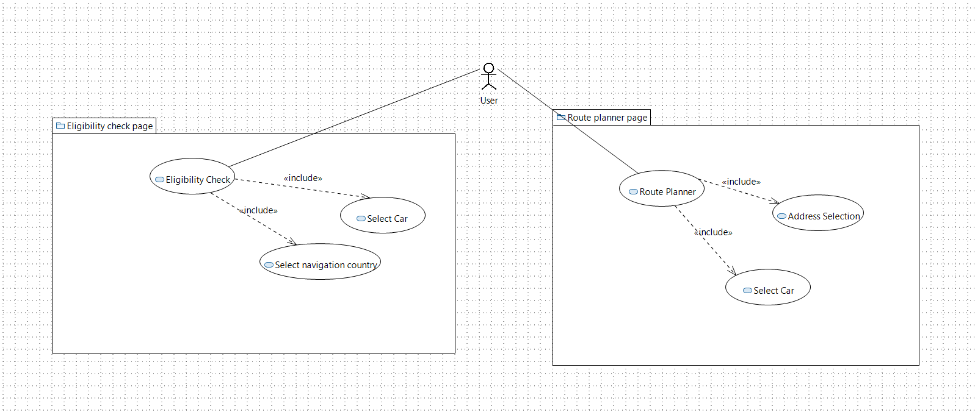
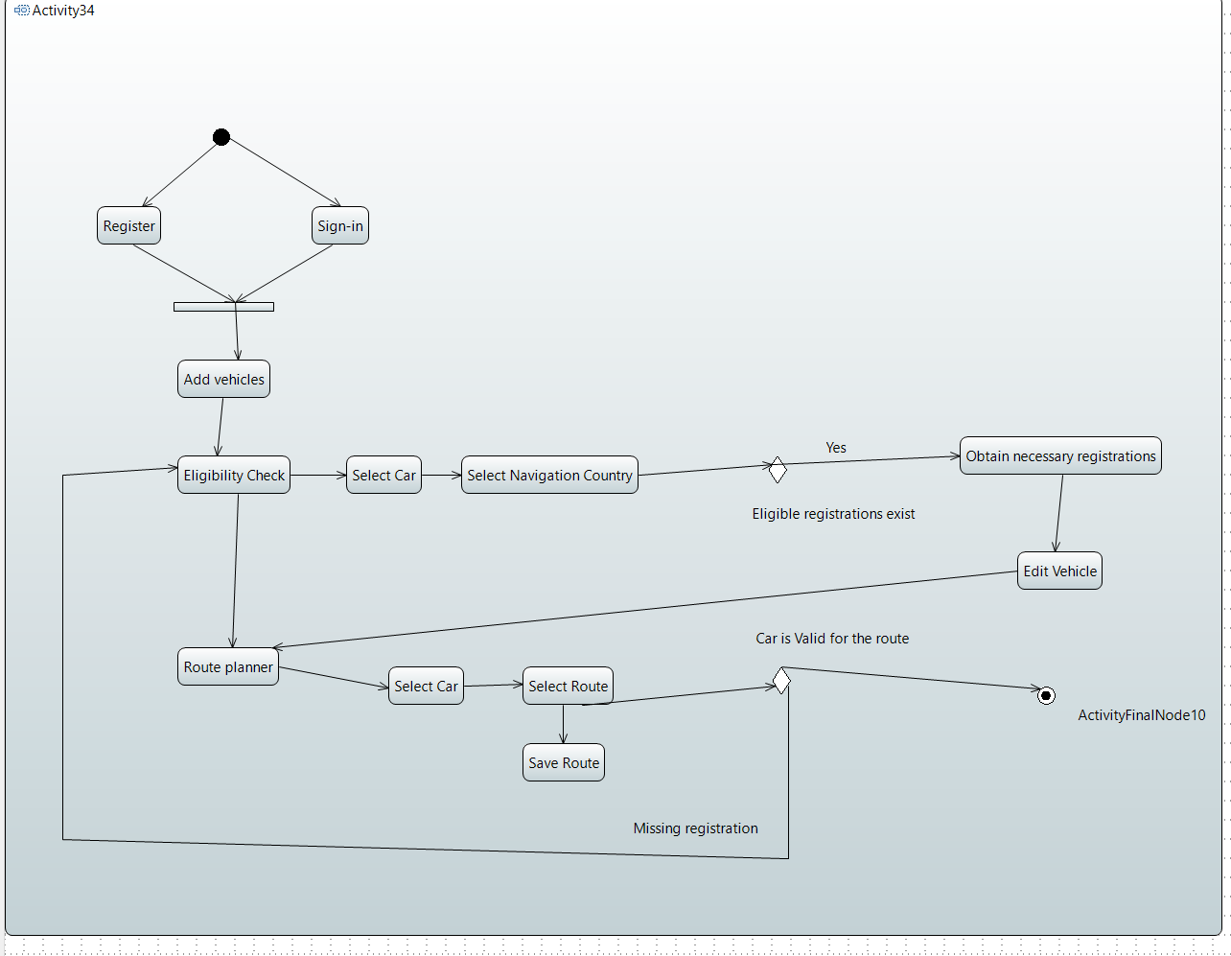
-> dpdv tehnic
-> dpdv utilizator

6.1.3 Functionalities

6.1.4 Constraints and Other Non-functional Requirements
(de ex. Faptul ca aplicatia este destinata momentan doar pentru masini de categorie mica -> totusi se poate extinde usor pentru a acoperii si alte categorii de vehicule)

6.2 Design Elements

6.2.1 Architecture
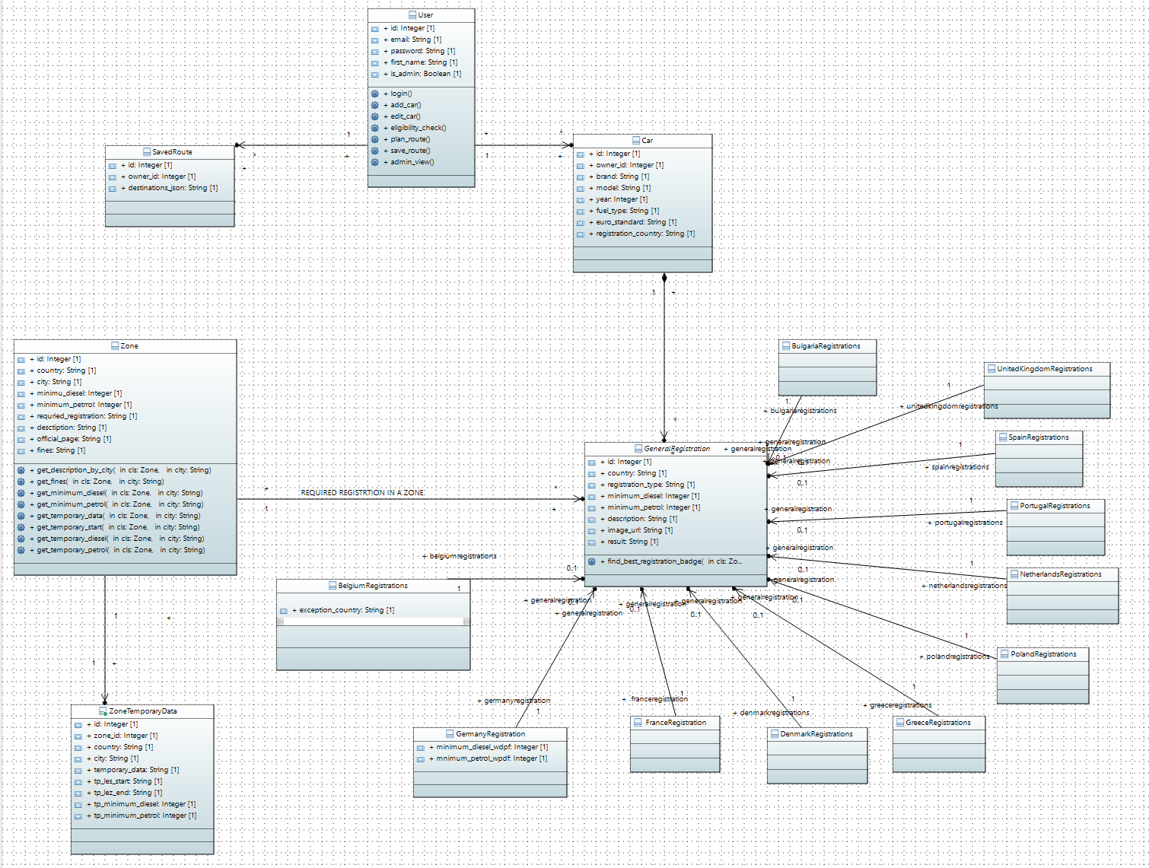

7 Description of the Practical Application

7.1 User Guide

7.2 Application Verification and Validation

7.3 Results Obtained

8 Conclusions

Bibliography

[1] https://www.europarl.europa.eu/topics/en/article/20190313STO31218/co2-emissions-from-cars-facts-and-figures-infographics. (n.d.).
[2] https://transport.ec.europa.eu/transport-themes/urban-transport/urban-vehicle-access-regulations_en
[3] https://dieselnet.com/standards/se/zones.php
[4] https://www.mdpi.com/2071-1050/15/23/16260
[5] https://dieselnet.com/standards/eu/lez.php
[6] https://www.germanemissionssticker.com/the-german-diesel-ban/
[7] https://www.france.fr/en/holiday-prep/crit-air-anti-pollution-vehicle-sticker
[8] https://urbanaccessregulations.eu/countries-mainmenu-147/france/paris
[9] https://www.statista.com/statistics/1321264/low-emission-zones-europe-by-country/
[10]https://www.london.gov.uk/who-we-are/what-london-assembly-does/questions-mayor/find-an-answer/usage-ultra-low-emission-zone-ulez-automatic-plate-recognition-cameras-crime-prevention-and
[11] Miguel Grinberg, Flask Web Development: Developing Web Applications with Python, O'Reilly Media, 2018
[12] Feng J, Hou H. Review of Research on Urban Social Space and Sustainable Development. Sustainability. 2023; 15(22):16130. https://doi.org/10.3390/su152216130
[13] https://www.w3schools.com/html/html5_geolocation.asp
[14]https://www.statista.com/statistics/1241923/worldwide-software-developer-programming-language-communities/
[15] https://survey.stackoverflow.co/2023/#overview
[16] https://flask.palletsprojects.com/en/3.0.x/
[17]https://www.redswitches.com/blog/flask-vs-django/#:~:text=Netflix%3A%20Netflix%20is%20among%20the,Flask%20to%20build%20internal%20tools.
[18] https://www.sqlite.org/lang_transaction.html
[19] https://realpython.com/python-sqlite-sqlalchemy/
[20] https://discovery.hgdata.com/product/sqlite
[21] https://react.dev/
[22] https://angular.io/
[23]https://developer.mozilla.org/en-US/docs/Web/JavaScript/Reference/Statements/async_function
[24] https://nodejs.org/en
[25]https://aws.amazon.com/what-is/api/#:~:text=APIs%20are%20mechanisms%20that%20enable,weather%20updates%20on%20your%20phone.
[26] https://www.altexsoft.com/blog/what-is-api-definition-types-specifications-documentation/
[27]https://www.ibm.com/topics/rest-apis#:~:text=A%20REST%20API%20(also%20called,transfer%20(REST)%20architectural%20style.
[28] https://api.first.org/
[29] https://developer.mozilla.org/en-US/docs/Web/HTTP/Methods
[30] https://flask.palletsprojects.com/en/2.3.x/tutorial/views/

Appendix 1. Code Snippets

@views.route('/new-car',methods=['POST','GET'])
@login_required
def new_car():
if request.method== 'POST':
owner_id=current_user.id
…
#registrations
france_reg=request.form.get('France_registration')
germany_reg=request.form.get('Germany_registration')
…
new_car Car(owner_id, … ,france_reg,germany_reg, …)
db.session.add(new_car)
db.session.commit()
flash('Car added. ', category='Success')
…

return render_template(“new_car.html”,user=current_user, …)

Ex. Code 1

